To Do’s from airplane home LHR-SAN

- Explore the relation between WoB and BN. The data flow makes it seem that the BN is constructed from the WoB, suggesting that all the effects and d size etc are encoded first in the web and then projected via pi to the BN. I need to understand this much better and so did Pearl. The paper Possible Replies to the Panel Critique: is a good start but falls way short of wht is required. Read my notes.
- er
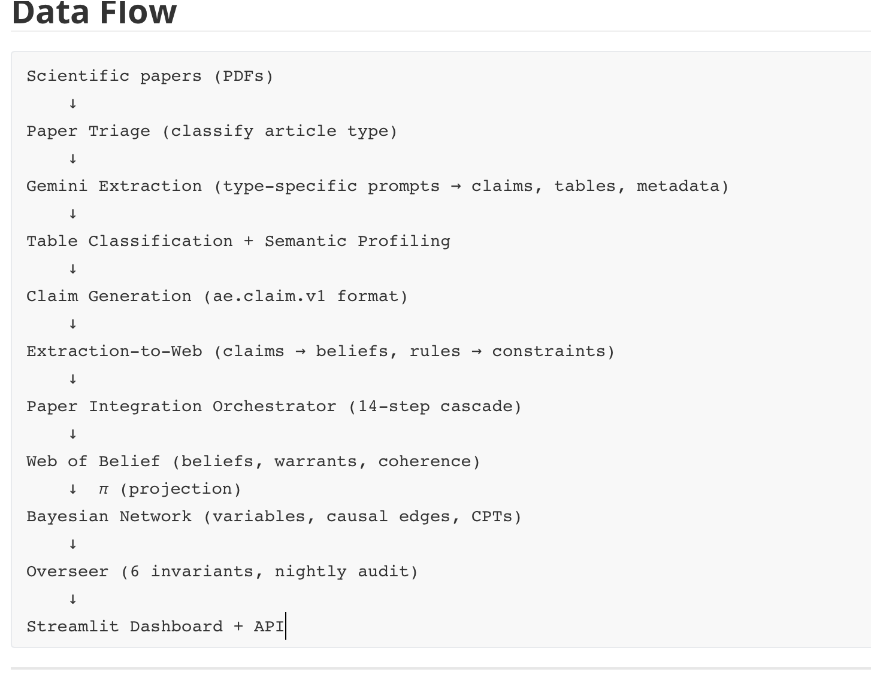
- review this doc on aleatoric and epistemic and critique it using a panel of super experts in the re

- Can we call the number attached to what (belief nodes?) to be believed or believability or credibility or current belief level or degree of belief rather than credence. This is supposed ot be different than the CPTS that link nodes between arch stims and psych/beh/neural states in the BN. I need this made super clear to me. What is the relation between the two numbers credibility or current degree of belief that A causes C vs conditional probability of the same claim. Presumably there are many more claims about A B in the web, such as what is happening at the neural mech level or the computational level – some deeper theory level where we describe the intermediate states in non observables or directly measureable form – though maybe later we can find direct measures for these. This suggests that the BN is a projection from the web that meets certain conditions – it will have fewer links /edges between (A,B). Maybe we have to look at the idea of a confound or an interaction to see the difference. Also the underlying states – could they be in the BN or is the theory that explains and justifies A B so borad that these are instances rather than being caused. Ie we distinghiosh a theory from a mechanism. Why?
- Give me the justification for each warrant. What makes anyone think they are complete. What makes anyone think they are consistent and sound. This either needs a proof or something like a proof. Is there a metamath proof related to models that can prove this? What are analogous cases where there is a graph system with these different edges. Can they be contradictory – make cycles and so on using the analytic techniques of graph theory to prove things. What do we mean by consistency here? Ask Pearl and some great hraph theory experts how to think about this problem.
- I have from chat a crappy doc or at least the saved ones are. But allegedbly there is a real article style doc about: aesthetic preference and its various causes originating in measurable attributes of stims or arch scenes (perhaps in a pic but perhaps in a VR scene or even in physical venues).
The question is: do any of these identified factors that often correlate with preference belong in our web as 1.5’s or molecules? Maybe they should tags that are useful for identifying correlations etc. We might also decide to add more tags than these too: perhaps tags relating to the different measures experimental studies use so we can then ask which studies measure eg respiration etc. Claude needs to be given the chat final doc and we ask it to understand what is written here.
- Claude must finish its health and maintenance processes. It must review its overseer and how effectively it can maintain the web and BN. And see that pipelines are continually in process and that HITL are notified whenever they can be useful.
- I could also ask Claude to help design a course where students choose a topic using ATLAS: A Case Study of a computational web of belief in cog neuroscience for architecture. The course would start by me reviewing the major areas of research and the major theories and the major ideas of this system and how it can be used to identify VOI and target preference experiments. Clearly I’d need quick adaptive preference or Implicit tests. So that would have to be built. But then I can image by week three they have chosen a gen topic. They have added lots of articles to our web. They then zero in on a specific hypothesis – they explain why. The system will help them with the VOI rationale but they hae to make sense of it. Then it helps them formulate a specific hypothesis. They would see what the methods are that similar experiments use for testing their related hypothesis. Then they get help designing the experiment and then make a plan for running it. They will have to make or find the stims. Ideally they would use VR but initially images would work. Maybe we can find a quick way to get VR from those images or create VR stims.

- My goal should be by Sun night to have a stable system that can be QA’ed. So the web browse and QA search should be working. Wth provenance. And with the source of degree of belief. Ultimately there should be a QA chain that delivers high VOI areas. But also the story line leading to it.
- AG: work on that Zotero thing and actually getting PDF’s.
- Chat follow up on aesthetics and maybe other topics, such as typologies. The activities that must be supported in different rooms in a typology and then the factors that can interfere with pure functionality based on affordances – such as noise, clutter, lighting, odor, interruption, … maybe we can get a list of these from the web of belief.
- Claude and chat and AG – run a ruthless.
- THE triad should also consider what best practices in design documentation and so on are we not following? Opportunities for improvement
- What are the papers that can be written for varios journals and on various topics.
  - CNfA. Philosophy of Science. Cognitive Science, AI – perjaps what this can do that LLM’s cannot without this type of structured knowledge.

- Have chat and AG review the Master dpc and review the codebase and the recent docs. What is missing?
- What remains blocked (needs AG on production server): The safe_improve_web_health.py script found 1,731 edges to add that would cut the orphan rate roughly in half, but it can't write to the database from this read-only mount. The AG_DATABASE_FIX_REPORT.md has the exact commands AG needs to run. Expected improvement: AESHI 49 → 53–55 from that single action alone.
- The article by chat against the necessity of a concept of beauty in architectural cognition might be generalized to show that not only is beauty reducible so are many of the other concepts at the same level of analysis. Ie we posit beauty as an organizing principle. People find lots of things beautiful. Is there a beauty property that we are ‘picking up’ – some decidable attribute of arch interiors, exteriors, landscaping that we register and individual differences can be explained.
- Chat used the term appraisal hubs – hubs are a graph theoretic term. So what is this about in the web? Do BN’s have hubs too? Do we have levels of analysis in BN and in the web?
- Review each pipeline for automation and completeness. Where are illustrations of stimuli or env context extracted? I need those. Also do the article templates match the ones I worked on? Make a list of these pipelines. See pipeline audit – for processing articles into article templates. Another should be finding articles and downloading the pdfs. Another should be taking the stack of article templates and encoding them in the Web and the BN, including adding the tags/annotations. Another that we have not discussed in a long time is find images, parse images, classify images multiply. Another might be finding tags and descriptors for antecedents – ie properties of the contextual situation a person might be in in an architectural case (including affordance ecologies), and the consequents of that situation (including their task). Consequents include change in performance or possibilities for action, change in mental state, mental performance, mood/emotion/feeling, physiological state, health/wellness, short and long term effects, specific psych measures like creativity, focus, mental endurance (stick to itness – is there a measure for ‘mental tenacity’ or ‘will to complete’ or mental endurance.

